Final Project Report

Detection of Cyberbullying using
Machine Learning



Project Supervisor

Muhammad Tayyab Waqar

Submitted By

F2102102BC
Tayyba MC200403615
Hiba Nishat Anjum MC200403928

Software Projects & Research Section,
Department of Computer Sciences,
Virtual University of Pakistan


CERTIFICATE

This is to certify that Tayyba (MC200403615), Hiba Nishat Anjum(MC200403928) have worked on and completed their Software Project at Software & Research Projects Section, Department of Computer Sciences, Virtual University of Pakistan in partial fulfillment of the requirement for the degree of BS in Computer Sciences under my guidance and supervision.

In our opinion, it is satisfactory and up to the mark and therefore fulfills the requirements of BS in Computer Sciences.

Supervisor / Internal Examiner

Muhammad Tayyab Waqar
Supervisor,
Software Projects & Research Section,
Department of Computer Sciences
Virtual University of Pakistan

___________________
(Signature)

External Examiner/Subject Specialist
<<External Supervisor Name>>

___________________
(Signature)

Accepted By:

_____________
(For office use)

EXORDIUM

In the name of Allah, the Compassionate, the Merciful.

Praise be to Allah, Lord of Creation,
The Compassionate, the Merciful,
King of Judgment-day!

You alone we worship, and to You alone we pray for help,
Guide us to the straight path

The path of those who you have favored,

Not of those who have incurred your wrath,
Nor of those who have gone astray.

DEDICATION

I dedicate this research study to the Holy Prophet Hazrat Muhammad (S.A.W.W) Whose single sentence “ Getting Knowledge is obligatory to every Muslim (Man and Woman)’’ paved the way for powerless and feeble beings like me to reach at the highest level of education. Especially to my loving Parents and respected Teachers who illuminated the candle of humanity and Islam in my heart.
T.H

ACKNOWLEDGEMENT

We offer our gratitude to ALLAH ALMIGHTY, the beneficial and the most Merciful, who made us human, blessed us with marvelous knowledge and enabled me to complete my research work. Without ALLAH’s blessing, we would not be able to accomplish this task effectively in the prescribed time, we want to extent our deepest gratitude to our parents, without the endless love, motivation, and prayers from our parents; it would not have been possible to accomplish this success that we have achieved. Their unflinching support and encouragement has been driving force behind this accomplishment.
We also would like to thank to our supervisor Muhammad Tayyab Waqar, his encouragement and guidance sparked our interest even in the field of Computer Science. He spent many hours guiding us in the best possible manners and correcting our mistakes. We would also like to thank all the teachers of Computer Science department who motivated us regarding to our research. We are also grateful to all our caring, loving friends, siblings and well-wisher, who helped us in all the possible aspects and never let our spirits dwindle away even for a tiniest bit.
PREFACE

Cybercrime has emerged as a result of rising Internet usage and easier access to online groups like social media. Today, cyber bullying is a pretty regular occurrence. This in the recent days has no tracking and could be harmful to any individual, business, society, or nation. Cyber bullying has become a severe issue affecting kids, teens, and young adults as a result of social media becoming more and more prevalent. Automatic detection of bullying-related posts in social media is now possible due to machine learning techniques, which may contribute to the creation of a positive and secure online community. This study discusses experiments with sentiment analysis of comments about Cyber bullying are presented and discussed. This study wants to determine whether comments may be categorized as expressing both a bullying and Non-bullying comments. Word embedding generated by TF IDF are typically used to generate high-dimensional vectors in a space and learn context. Then, machine-learning methods are used to categorize these embedding. Using Comment length and language to select the most accurate way to analyze comments is one of the challenges of applying TF-IDF to message sentiment classification.
Using Machine learning models, 90% comments may be classified with the highest degree of accuracy. The Random forest Tree along with the TF-IDF training model, were used to make this prediction.
Index Terms: Social Media, Sentiment analysis, Word embedding, Classification, TF-IDF

TABLE OF CONTENTS

Chapter no 1 11
Gathering and Analyzing Info 11
1.1 Introduction 12
1.1.1 Common kind of cyber-bullying on these sites 13
1.1.2 Types of Cyber-bullying 13
1.2 purpose 14
1.3 Scope 14
1.4 Definitions, acronyms, and abbreviations 15
1.4.1 Definitions 15
1.4.2 Acronyms 15
1.4.3 Abbreviation 15
1.5 Project requirements 15
1.5.1 Functional Requirements 16
1.5.2 Non-Functional Requirements 17
1.6 Use cases and usage scenarios 18
1.6.1 Use Case Diagrams 18
1.6.2 Usage Scenarios 19
1.7 Development Methodology 27
1.7.1.1 Waterfall Methodology: 28
1.7.1.2 Spiral model: 28
1.7.2 Chosen Methodology 29
1.7.2.1 Model of the VU Process: 29
1.7.2.2 Reasons for Chosen Methodology 30
1.7.3 Work Plan (Gantt chart) 31
1.7.4 Project Schedule (Submission Calendar) 32
CHAPTER 2 34
Designing the Project 34
2.1 Introduction 35
2.2 Purpose 35
2.3 Scope 36
2.4 Definitions, acronyms and abbreviations 36
2.4.1 Definitions: 36
2.4.3 Abbreviation 36
2.5 Architectural Representation (Architecture Diagram) 37
2.6 Dynamic Model: Sequence Diagrams 38
2.7 Object Model/Logical Model: Class Diagram 39
2.8 Database Model (Database Diagram) 40
2.9 Graphical User Interfaces 41
2.9.1 Test case 1: 41
2.9.2 Test case 2: 42
2.9.3 Test case 3: 42
2.9.4 Test case 4: 43
2.9.5 Test case 5: 43
2.10 Test Cases Scenario 44
CHAPTER 3 46
Development 46
3.1 Development Plan 47
3.1.1 Technique of detection: 47
3.1.1.1 Dataset Collection & Preparation 47
3.1.1.2 Pre-Processing 48
3.1.1.3 Feature extraction or Modeling 48
3.1.2 Machine Learning Classification: 48
3.2 Evaluation and deployment: 49
3.3 Conclusion 51
3.4 FUTURE SCOPE 51
REFERENCES 52
APPENDIX A 54
Appendix B 55
Appendix C 56
Appendix D 57

List of Figures

Figure 1 Use case Diagram of Cyber-bullying Detection using ML 17
Figure 2 Step of Waterfall Model 26
Figure 3 Steps of Spiral Model 27
Figure 4 VU Model Combinations of Waterfall and Spiral 28
Figure 5 Gantt chart of work plan 29
Figure 6 Architecture Design Diagram 34
Figure 7 Sequence Diagram of Cyber-bullying detection 35
Figure 8 Sequence Diagram of Cyber-bullying detection 36
Figure 9 ERD of Cyber-bullying Detection 37
Figure 10 Test case1 Anaconda Interface 38
Figure 11 Test case 2 Jupytor Interface 39
Figure 12 Test case3 Final Code Using Python 39
Figure 13 Test case 4 Classification of Algorithms 40
Figure 14 Test case 5 Accuracy score of ML Techniques 40
Figure 15 Development plan of Cyber-Bullying Detection using Machine Learning Techniques 43

List of tables

Table 1 Use Case Scenario of Data Collection 16
Table 2 Use Case Scenario of Data Preparation 17
Table 3 Use Case of Cleaning dataset 18
Table 4 Use Case Scenario of Pre-processing 18
Table 5 Use Case Scenario of Feature Extraction 19
Table 6 Use Case Scenario of Train and test 20
Table 7 Use case Scenario of choosing model 20
Table 8 Use Case Scenario of ML techniques 21
Table 9 Use Case Scenario of Prediction 22
Table 10 Use Case Scenario of Confusion Matrix 22
Table 11 Use Case Scenario of Accuracy Evaluation 23
Table 12 Test Case1 39
Table 13 Test case2 40
Table 14 Test Case3 40
Table 15 Test Case4 40
Table 16 Test case5 40
Table 17 Accuracy Percentage by Classifier and Training Model 44
Table 18 Classification Report of Multinomial Naïve Byes 44
Table 19 Classification Report of Naïve Bayes 45
Table 20 Classification Report of Decision Tree 45
Table 21 Classification Report of Random Forest Tree 46

Chapter no 1

Gathering and Analyzing Info

1.1 Introduction

Cyberbullying is when someone is abused through the use of technology. Bullies thrive on social networking sites, and teens and young people who use them are particularly vulnerable. We can discover language, and patterns used by bullies and their victims, and develop rules to automatically detect cyberbullying content using machine learning. Cyber-bullying is the use of technology to harass, threaten, embarrass, or make targeted sharing about another person. Adults can be victims of cyber-bullying, which is more common among young children and young people. Adults are subjected to harsh legal punishments, like prison sentences, in such circumstances.
In comparison to earlier bullying methods, cyber-bullying does not require physical force or face-to-face conversation. Cyberbullying can be carried out by anyone using any device with an Internet connection. Bullies might be anonymous or come from a child's or young person's close friends (Cyberian, 2021).
Cyberbullying is bullying that occurs with digital devices such as computers, cell phones, and tablets. It can be through online social media forums where people can view, participate, comment, or share other people's content. This may include sharing personal or private information about someone else that may cause embarrassment, such as sending, posting, or sharing negative, inaccurate, harmful material about someone else (Cyber Bulling, 2019).
Adolescents and teens can be severely harmed by cyberbullying. Anxiety, sadness, and even suicide are all possible outcomes. So, to address these difficulties, identifying cyberbullying is critical these days. To overcome these issues detecting cyberbullying is very important in now a day which will help to stop cyberbullying on social media networks.

1.1.1 Common kind of cyber-bullying on these sites
- Facebook, Instagram, Twitter, and Snap chat are all popular social media platforms.
- Instant messaging options provided by e-mail providers, programmers, or social networks Text messages sent by direct devices (SMS)
- E-mails and chat rooms.

1.1.2 Types of Cyber-bullying
Cyberbullying can be classified into several categories. In terms of structure, all of the acts you can encounter or experience may differ in some way.
You may be aware of the following difficulties to comprehend the situation or protecting your children from cyber-bullying:
- Disclosure:
Even though it is nearly impossible to remove and destroy information shared on the Internet, this practice might permanently harm the victim's digital reputation.
- Indictment:
Method of automating production through the use of electronic and information technology. Typically, these attacks are personal and cause the victim to become angry.
- Trolling:
When the pressure is put on the victim to blame and act, trolling is also a kind of cyber-bullying.
- Cheat and Blackmail:
By gaining the children's trust, the trickier can learn their secrets. Then they publicly share these secrets with the rest of the world via the internet. They sometimes utilize the information they obtain to blackmail people. These folks could be from your child's immediate circle or someone you've never met before.

1.2 purpose

The purpose of this project is the following:

- Real-time data
- Using data mining and a machine learning system
- Accessing a comment from the user's feed.
- Sentiment analysis
Sentiment Analysis is a term used to describe automated ways of extracting opinions from a piece of natural language text.
- Classification of sentiment
To put it another way, sentiment analysis determines whether a piece of text is positive or negative.

1.3 Scope
Our effort is mostly focused on detecting cyber-bullying on social media. The person who implements this project is dealing with cyber-bullying or wants to evaluate post comments. The main goal of the project is to analyze real-time data from user posts and then analyze the data in Excel. The text analysis sentiment analysis will be used to further analyze the CSV file.

1.4 Definitions, acronyms, and abbreviations

1.4.1 Definitions
- A software requirements specification (SRS) is a document that outlines the functions and performance standards for the software. Additionally, it outlines the functionality that the product must have to satisfy all customers (Perforce Software, 2022).
- According to the Perforce Software (2022), in-depth details of the software that will be built are included in a software requirements specification (SRS).

1.4.2 Acronyms

SRS System Requirement Specifications

1.4.3 Abbreviation

UCD Use Case Diagram
UCS Usage Case Scenario

1.5 Project requirements

The term requirement refers to a condition or capacity that the system must meet. Requirement Management is a method for eliciting, organizing, and documenting the system's needs, as well as the qualities that apply to them. The difficult challenges of requirements can arise from a variety of places and are not always visible.
The project requirement includes the SRS design. A Software Requirement specification is a document that captures a complete description of how the system will work. It lays out Functional and non-Functional requirement; it also includes a set of use-cases. That describes user interactions that software must provide. It also includes usage scenarios and adopted methodology. In a wide range of real-world settings, a good SRS defines how an application will interact with system hardware, other software, and human users.
SRS is a document that fully specifies what the proposed software should do without specifying how it will do it. It's a two-way insurance policy that ensures that both the client and the company are aware of each other's requirements at any given point in time (Cyberian, 2021).
SRS also serves as a roadmap for completing a project with the least amount of cost rise achievable. Because all following project management documents, including design specifications, statements of work, software architecture specifications, testing and validation plans, and documentation plans, are related to SRS. It is commonly referred to as the parent document.

1.5.1 Functional Requirements

Functional Requirement defines a function of a software system and how the system must behave when presented with specific inputs or conditions
- Data-collection
For this project, we can collect data from any social media platform (such as Facebook, Twitter, or YouTube) to detect cyberbullying.
- Data-Preparation
After collecting the data, we prepare the data set. In the process, we will label these comments in two classes: B (bullying) and NB (non-bullying).
- Cleaning Dataset:
We will remove punctuation marks and digits from the data set.
- Pre-processing
As most of the data in the real world are incomplete containing noisy and missing values. Therefore, we apply to pre-process your data. In pre-processing, we will normalize the data set, remove duplicate values, handle noise & outliers, missing values, and stop words.
- Feature Extraction
After the pre-processing step, we will apply the feature extraction method. We can use TF-IDF, Word2Vec, Uni-Gram, Bi-Gram, Tri-Gram, or N-gram feature extraction method.
- Train & Test Data
Split data into 70% training & 30% testing data sets.
- Choosing Model
There are numerous models from which to choose depending on your objective. We will use classification algorithms.
- Machine learning Techniques
In this project, we use a minimum of four classifiers/models e.g. Naive Bayes, Naive Bayes MN, Decision Tree, Random Tree, and Random Forest Tree of four machine learning techniques/algorithms.
- Model Evaluation:
To evaluate the performance of our machine learning model, we compute different metrics.
- Confusion Matrix
Create a confusion matrix table to describe the performance of a classification model.
- Accuracy Evaluation
Find the accuracy of all techniques and compare their accuracy.
- Inference vs. prediction
We may now use your Machine Learning model to infer outcomes in real-world scenarios. The model should produce a corresponding output that does not differ from the expected outcome.
- Best Detection Techniques:
This project will also tell us which machine learning technique is best for detecting cyberbullying.

1.5.2 Non-Functional Requirements
Non-functional requirements are the requirements that are not directly concerned with the specific function delivered by the system. They specify the criteria that can be used to judge the operation of a system rather than specific behaviors. These are the following:
- Correctness:
It followed a well-defined set of procedures and rules to compute and also rigorous testing is performed to confirm the correctness of the data.
- Ease of Use:
Model Coder provides an interface that allows the user to interact efficiently.
- Modularity:
The complete product is broken up into many modules and well-defined interfaces are developed to explore the benefit of flexibility of the product.
- Robustness:
This software is being developed in such a way that the overall performance is optimized and the user can expect the results within a limited time with relevancy and correctness.
- Scalability:
Establishing strong scalability requirements can help your team define how to measure the success of your system's ability to scale.
Non-functional requirements are also called the qualities of a system. These qualities can be divided into execution quality & evolution quality. Execution qualities are security & usability of the system which are observed during run time, whereas evolution quality involves test-ability, maintainability, extensibility, or scalability.

1.6 Use cases and usage scenarios

1.6.1 Use Case Diagrams

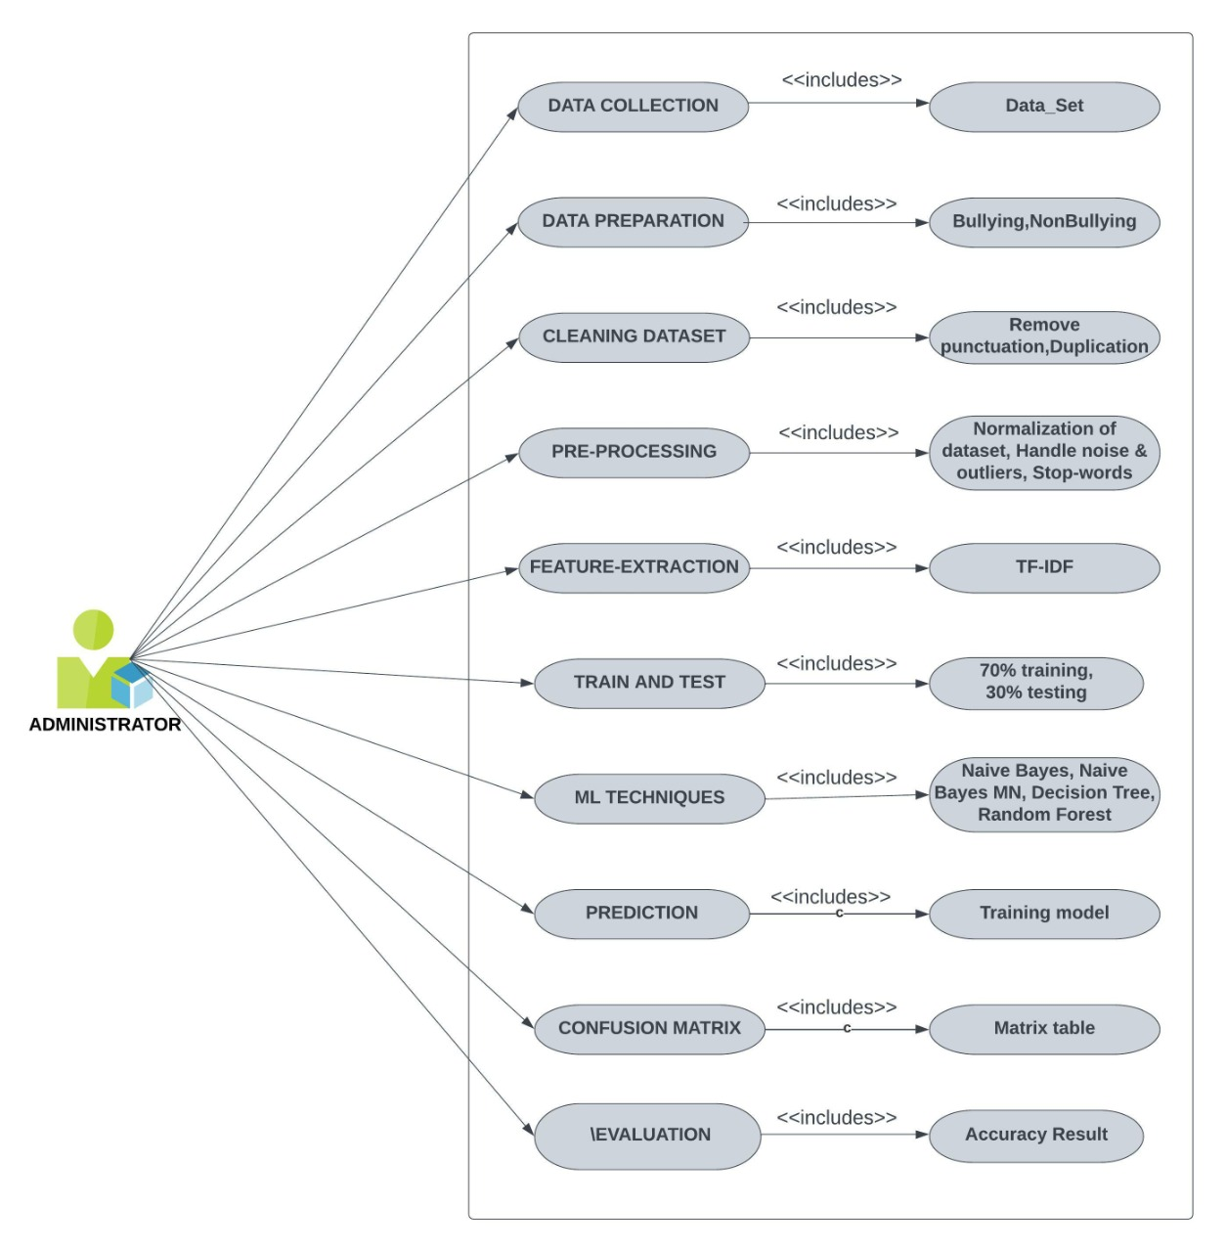
Figure 1 Use case Diagram of Cyber-bullying Detection using

1.6.2 Usage Scenarios

Table 1 Use Case Scenario of Data Collection
 | UCS 1
Use case title |  | Data Collection
Abbreviated title |  | DC
Use case ID |  | CBML
Actors |  | Administrator
Description |  | In this process, administrator collects the cyber bulling data.
Task sequence |  |  |  | Exceptions
1. Administrator open any social media website/application like Facebook, tweeter, YouTube, Instagram etc. |  |  |  | 1. Administrator doesn’t open any application/website.
Pre-Condition |  |  |  | Collecting dataset from YouTube, Facebook and API
Post Condition |  |  |  | Dataset collected
Author |  |  | F2102102BC

Table 2 Use Case Scenario of Data Preparation
 | UCS 2
Use case title |  | Data Preparation
Abbreviated title |  | DP
Use case ID |  | CBML
Actors |  | Administrator
Description |  | After completing data, prepare the dataset.
Task sequence |  |  |  | Exceptions
1. After completing data, administrator needs to prepare dataset.  2. In the process, administrator needs to label these comments in two classes:  - B (Bullying)  - NB (non-bullying) |  |  |  | 1. Without data, administrator not be able to complete dataset.
Pre-Condition |  |  |  | Collect the data and prepare dataset.
Post Condition |  |  |  | After completing dataset, label comments in two classes: Bullying and Non-Bullying.
Author |  |  | F2102102BC

Table 3 Use Case of Cleaning dataset
 | UCS 3
Use case title |  |  | Cleaning Dataset
Abbreviated title |  |  | CD
Use case ID |  |  | CBML
Actors |  |  | Administrator
Description |  |  | Administrator needs to remove punctuation marks and digits from dataset.
Task sequence |  |  |  | Exceptions
1. Our dataset contains punctuation marks and digits, we need to remove it. |  |  |  | 1. Punctuation marks and digits contain error.
Pre-Condition |  |  |  | Remove Punctuation marks and digits.
Post Condition |  |  |  | Dataset contains only string. Or Data Cleaning is complete.
Author |  | F2102102BC

Table 4 Use Case Scenario of Pre-processing
 | UCS 4
Use case title |  | Pre-processing
Abbreviated title |  | PP
Use case ID |  | CBML
Actors |  | Administrator
Description |  | Administrator needs to normalize the dataset, remove duplicate values, handle noise & outliers, missing values, and stop words.
Task sequence |  |  |  | Exceptions
1. Most of the data in the real world are incomplete that contain noisy and missing values. So, administrator needs to apply pre-processing on data.  2. In pre-processing, administrator needs to:  - Normalize the dataset.  - Remove duplicate values  - Handle noise & outliers  - Missing values  - Stop words |  |  |  | 1. Administrator doesn’t maintain the data for dataset.
Pre-Condition |  |  |  | Data contains noisy and missing values.
Post Condition |  |  |  | Administrator applies pre-processing on data to remove missing values and duplication.
Author |  |  | F2102102BC

Table 5 Use Case Scenario of Feature Extraction
 | UCS 5
Use case title |  | Feature Extraction
Abbreviated title |  | FE
Use case ID |  | CBML
Actors |  | Administrator
Description |  | After pre-processing, administrator will apply feature extraction methods.
Task sequence |  |  |  | Exceptions
1. Administrator needs to apply TF-IDF, Word2Vec feature extraction method. |  |  |  | 1. Feature extraction method requires some techniques for pre-processing.
Pre-Condition |  |  |  | Pre-processing of data must be complete for feature extraction method.
Post Condition |  |  |  | Word2Vec method is used as feature extraction method.
Author |  |  | F2102102BC

Table 6 Use Case Scenario of Train and test
 | UCS 6
Use case title |  | Train & Test Data
Abbreviated title |  | TTD
Use case ID |  | CBML
Actors |  | Administrator
Description |  | After collecting and pre-processing dataset, administrator needs to train and test data.
Task sequence |  |  |  | Exceptions
1. While completing the task of collecting, pre-processing and feature extraction method, data is prepared for training and testing.  2. Divide data into 70% training and 30% for testing data sets. |  |  |  | For accuracy, administrator doesn’t need train & test.
Pre-Condition |  |  |  | Data pre-processing is essential to prepare for train & test.
Post Condition |  |  |  | After preparing dataset completely, split data into 70% for training and
Author |  |  | F2102102BC

Table 7 Use case Scenario of choosing model
Use case title | Choosing Model
Abbreviated title | CM
Use case ID | CBML
Actors | Administrator
Description | Choosing model depend on objective from different models.
Task sequence |  |  | Exceptions
1. Administrator has a choice of models for choosing model depending on their own objectives.  2. Administrator will use classification algorithm technique for choosing model. |  |  | 1. With numerous models, administrator will not be able to choose model.
Pre-Conditioned |  |  | Administrator has a choice of models for choosing model.
Post Condition |  |  | Administrator used classification algorithm technique for choosing model.
Author |  | F2102102BC

Table 8 Use Case Scenario of ML techniques
 | UCS 8
Use case title |  | Machine Learning Techniques
Abbreviated title |  | MLT
Use case ID |  | CBML
Actors |  | Administrator
Description |  | Use machine learning techniques to detect bullying and non-bullying behavior.
Task sequence |  |  |  | Exceptions
Administrator will use machine learning techniques like Naive Bayes, Naive Bayes MN, Decision Tree, Random Tree and Random Forest Tree. |  |  |  | Administrator doesn’t maintain machine learning techniques.
Pre-Condition |  |  |  | Administrator will apply techniques to detect algorithm.
Post Condition |  |  |  | Four techniques will apply for machine learning algorithm.
Author |  |  | F2102102BC

Table 9 Use Case Scenario of Prediction
 | UCS 9
Use case title |  | Inference vs. prediction
Abbreviated title |  | IP
Use case ID |  | CBML
Actors |  | Administrator
Description |  | After machine learning techniques to detect bullying and non-bullying, administrator needs to inference and predicts the expected outcomes.
Task sequence |  |  |  | Exceptions
1. Administrator use machine learning model to infer outcomes in real-world scenarios.  2. At the result, prediction does not differ from expected outcomes. |  |  |  | With detection of bullying and non-bullying, inference and prediction produce expected outcomes.
Pre-Condition |  |  |  | Administrator apply machine learning model for infer and predict outcomes in real-world scenarios.
Post Condition |  |  |  | At the output result, prediction does not differ from expected outcomes.
Author |  |  | F2102102BC

Table 10 Use Case Scenario of Confusion Matrix
 | UCS 10
Use case title |  | Confusion Matrix
Abbreviated title |  | CM
Use case ID |  | CBML
Actors |  | Administrator
Description |  | Administrator needs to create a confusion matrix table to describe the performance and accuracy of a classification model.
Task sequence |  |  |  | Exceptions
Administrator will create a confusion matrix table.  Confusion matrix tables will describe the performance of a classification model. |  |  |  | With ML techniques, confusion matrix table is not built for classification.
Pre-Condition |  |  |  | First creates a confusion matrix table.
Post Condition |  |  |  | Confusion matrix tables will describe performance of accuracy and classification of a model.
Author |  |  | F2102102BC

Table 11 Use Case Scenario of Accuracy Evaluation
 | UCS 11
Use case title |  | Accuracy Evaluation
Abbreviated title |  | AE
Use case ID |  | CBML
Actors |  | Administrator
Description |  | After creating a confusion matrix table, administrator needs to find the accuracy of a model.
Task sequence |  |  |  | Exceptions
1. Administrator needs to find the accuracy by comparing all the techniques used in model.  2. At the end, administrator needs to check which machine learning technique is best for detecting cyber bullying. |  |  |  | 1. Remove all the techniques for accuracy evaluation.
Pre-Condition |  |  |  | Use different techniques to find accuracy.
Post Condition |  |  |  | The project will also tell us which machine learning technique is best for detecting cyber bullying.
Author |  |  | F2102102BC

1.7 Development Methodology

The terms software development methodology and system development methodologies are interchangeable. This is the system development life cycle, or System Development Process as it is also known. Software development techniques are frameworks for structuring, controlling, and planning the system development process.
There are multiple models for such processes, each giving a distinct approach to certain tasks or activities that occur within the process.
There are numerous approaches available nowadays. According to their needs and the nature of their work, people used a range of models. The following are the names of some of the methodologies:
- Agile software development methodology
- Waterfall methodology and Spiral methodology
- Lean software development methodology
- Scrum software development methodology
- Extreme programming (XP)
But we must select the VU Process Model, which combines waterfall and spiral models. Both the models, Waterfall and spiral model are used in software development. Waterfall model is also known as classical or linear model because it follows sequential stages while the spiral model does not follow the sequential stages it follows the evolutionary way.

1.7.1.1 Waterfall Methodology:
Waterfall model works in sequential method. In waterfall model errors or risks are identified and rectified after the completion of stages. It is related to the analysis, design, coding, testing, and maintenance cycles (Cyberian, 2021). The waterfall methodology is the most basic variation of the waterfall methodology.

- The system's services, restrictions, and goals are defined by consulting with users. The need is divided into two categories: hardware and software systems.
- It describes the system's overall architecture. The system has been installed and is ready to use. The system detects faults, corrects them, and improves the situation.

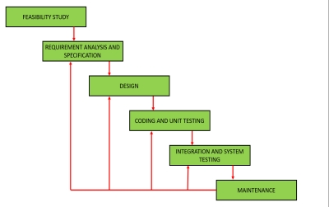
Figure 2 Step of Waterfall Model

1.7.1.2 Spiral model:
The spiral process is intended to avoid the risks that can arise during software development. The spiral model is extremely risk-averse. The development and maintenance of the spiral run concurrently due to its spiral shape. This strategy is used for large-scale and in-house software development. In a Spiral Model, there are two dimensions:
- A radial dimension that represents the total cost up to this point.
- An angular dimension that represents the spiral's development.
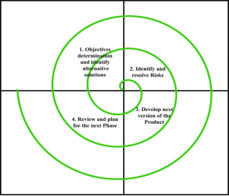
Figure 3 Steps of Spiral Model

1.7.2 Chosen Methodology

We will use the VU process model methodology to meet the requirements. The VU process model is described as follows:

1.7.2.1 Model of the VU Process:
The waterfall and spiral methodologies are combined in the VU Process Model. It's also known as a hybrid system development technique. It is divided into five phases.
- Gathering and Analyzing requirement
- Planning
- Analysis and Design
- Development phase
- Final Report
After a discussion with users, system goals, services, and limitations are developed in the requirement phase. The goals of the system, services, and constraints are developed in the requirement phase. The planning phase is a coordinated effort to uncover all of the potential for each task. It improves the system's quality while reducing risks and faults.

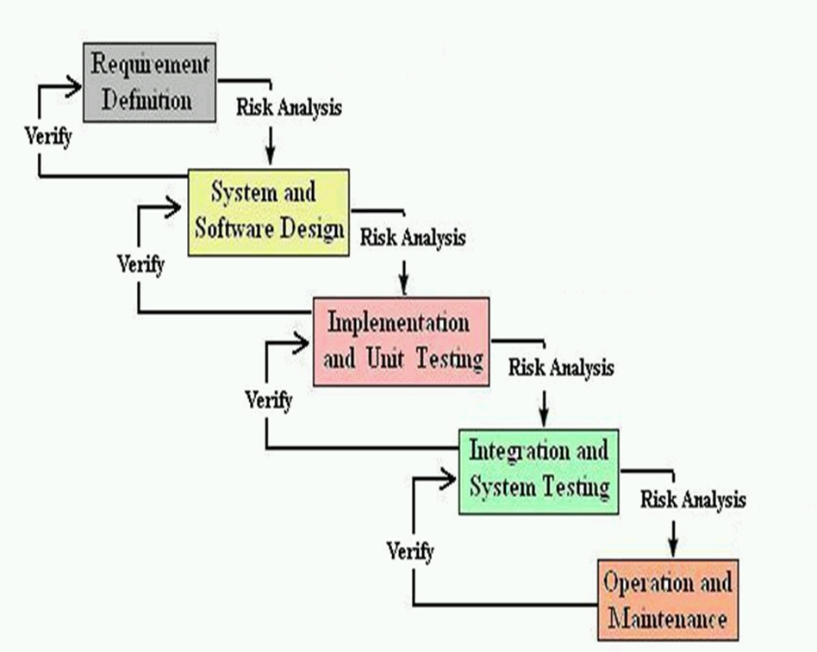
Figure 4 VU Model Combinations of Waterfall and Spiral

1.7.2.2 Reasons for Chosen Methodology

The VU Process model was chosen for the following reasons:
- Gathering and analyzing requirements phase, planning phase, analysis and design phase, development and final project report phase, and final report/viva phase are all phases of our project.
- Each phase will be completed in order, and we will submit it to our supervisor. Before moving on to the next phase, he will make suggestions for improvement in each phase. During that point, we will improve. Due to the spiral structure of the VU Process model, this process will be used.
- We will go on to the next phase once the previous phase has been enhanced and well-worked out, as well as approved by our supervisor. Due to the waterfall nature of the VU Process model, this will be done. As a result, both models are suppressed in a single form, which becomes our VU process model. Because each step is completed in order, the result will be error-free.

1.7.3 Work Plan (Gantt chart)

Gantt charts are helpful for project planning and scheduling. They assist you with determining how long a project should take, determining the resources required, and planning the order in which tasks will be completed. They're also useful for keeping note of task dependencies.

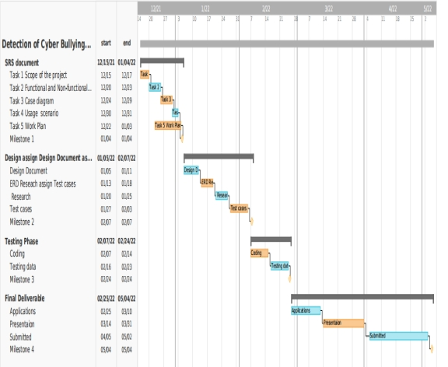
Figure 5 Gantt chart of work plan

1.7.4 Project Schedule (Submission Calendar)

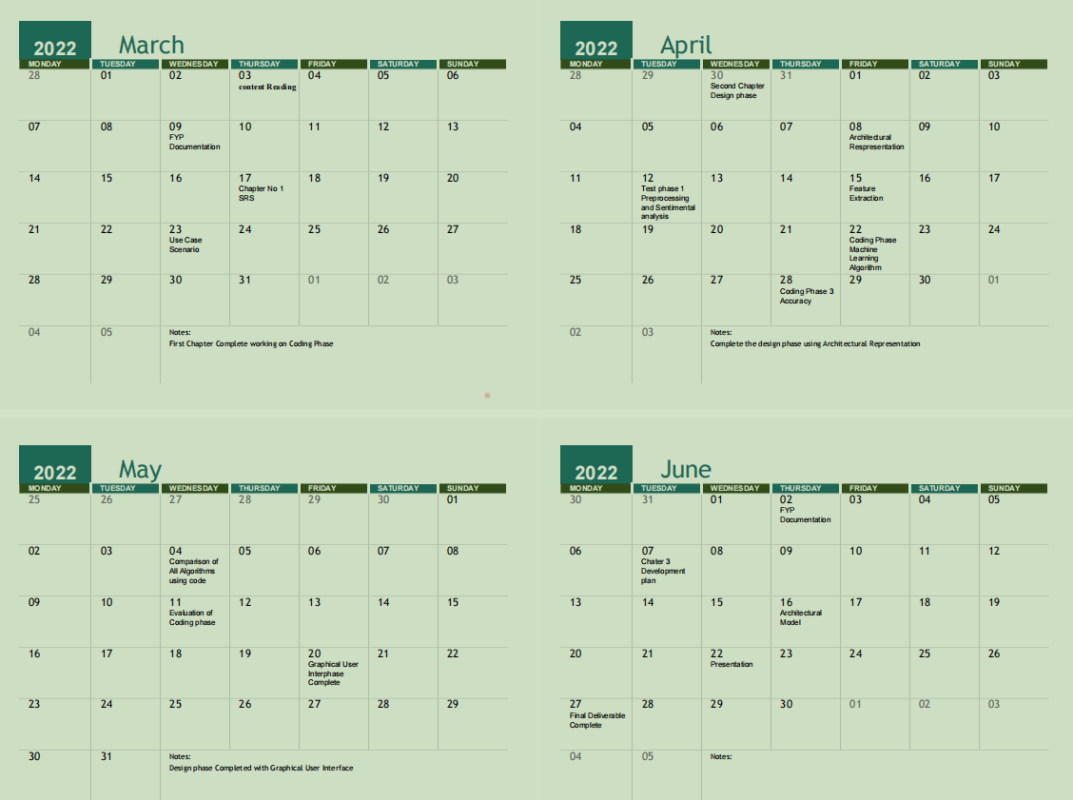
Figure 6 Submission Calendar

CHAPTER 2

Designing the Project

2.1 Introduction

A design is a document that captures a complete description of how the system will work systematically. A design document sometimes called a software design specification is a written report that describes the overall architecture of the software. It also includes data-set design and GUI design to show the application that works practically. The documents represent a graphical view and research methodology that is described to detect the cyber-bullying comments according to machine learning techniques. This plan is given out in a systematic method in the design document.
A design is an engineering representation of something that will be developed. It is the most important phase in a system's development. The process of translating requirements into a representation of software is known as software design. The main goal of the cyber-bullying detection model is to improve automated cyber-bullying monitoring on social media. The goal of this work is to describe a machine learning-based system design for detecting cyber-bullying. Design is an area in software engineering where design is emphasized.
The new system must be designed based on the user needs and a complete study of the present system. Design generates a model or representation of software data structure, architecture, interfaces, and other components required to implement a system.
This document is both graphically and textually presented. Finally, it includes a list of proposed Test cases for the system's Unit and integrated testing. By outlining the structure of the system to be developed, the design activity provides a roadmap for progressively transforming the requirements into the final product over several stages.

2.2 Purpose

The systems development and system administration goals are to:
- Collect and preprocess a dataset of bullying phrases
- Apply machine learning techniques.
- Create a variety of machine learning algorithm models, then apply them to the retrieved comments to determine if they are cyber-bullying or not.

2.3 Scope

In this project, we shall find the accuracy by applying appropriate machine learning techniques e.g., Bayesian, Tree and Random on cyber bullying datasets (ScikitLearn, 2022). We shall also compare what techniques are better for detecting cyber bullying and why.
- It will be significantly helpful to design automated, data-driven method for evaluation and detecting such harmful behavior in social media.

2.4 Definitions, acronyms and abbreviations

2.4.1 Definitions:

- Software design documentation (SDD) describes software designs for large-scale analysis, planning, implementation, and decision-making. A document, often known as a development timetable, is a set of specifications that outlines which products or features will be developed.
- According to the McNally Institutes (2022) is that a collection of documents and resources that covers all areas of your product design is known as design documentation. Users, product features, and project deadlines should all be documented, as should any necessary implementation details and design decisions reached by your team.

2.4.2 Acronyms

SDD Software Design Documents
SDD Software Design and Development

2.4.3 Abbreviation

GUI Graphical User Interface
TC Test Cases

2.5 Architectural Representation (Architecture Diagram)

An architecture diagram is a system diagram that describes the overall structure of a software system as well as the interactions, constraints, and boundaries between its components. Relationships with external components such as users, databases, and services are described.

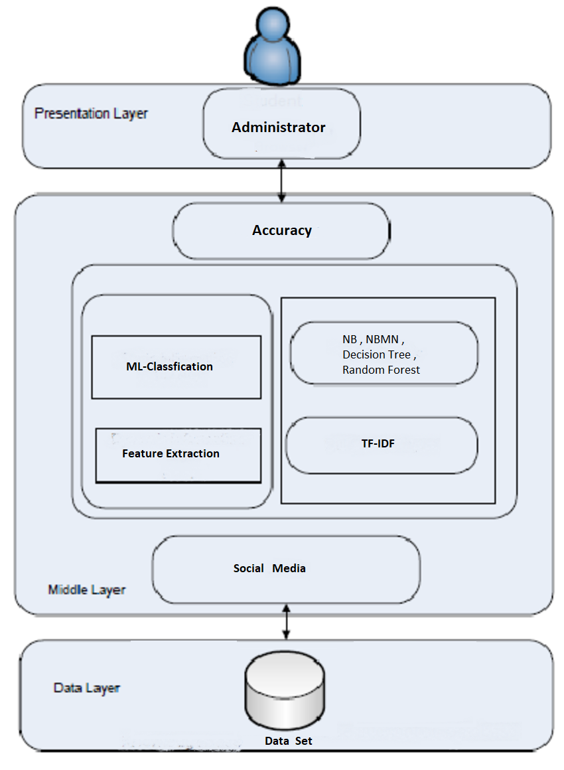
Figure 7 Architecture Design Diagram

2.6 Dynamic Model: Sequence Diagrams

In design, sequence diagrams are used to model the interactions between items in a single-use case. They show how the various pieces of a system communicate with one another to perform a function, as well as the order in which the interactions take place when a specific use case is executed.

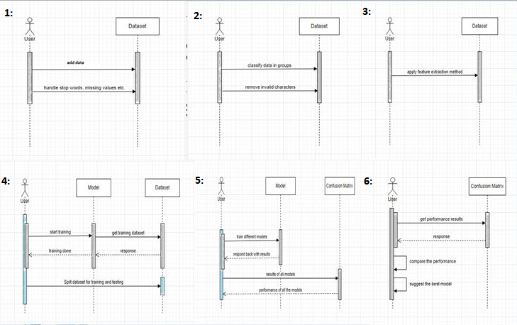
Figure 8 Sequence Diagram of Cyber-bullying detection

2.7 Object Model/Logical Model: Class Diagram

This dataset is made up of user comments on various posts. The writings or remarks were divided into two categories:
- Non-bullying Text: These are either non-bullying or pleasant remarks or posts. This shot, for example, is particularly wonderful because of the nice and non-bullying remarks.
- Bullying Text: This category refers to bullying or harassment comments. Go away bitch, for example, is a bullying text or message that we regard to be a nasty comment.
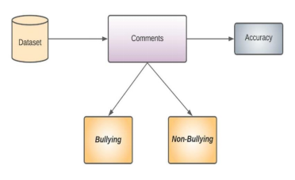
Figure 9 Sequence Diagram of Cyber-bullying detection

2.8 Database Model (Database Diagram)

The second step of the design document is to create the ERD to show the relationship in the detection of cyber-bullying using machine learning. The Rectangle shape describes the entity and the oval shape explained the attributes of the entity. The diamond shape represents the action performed by the entity.
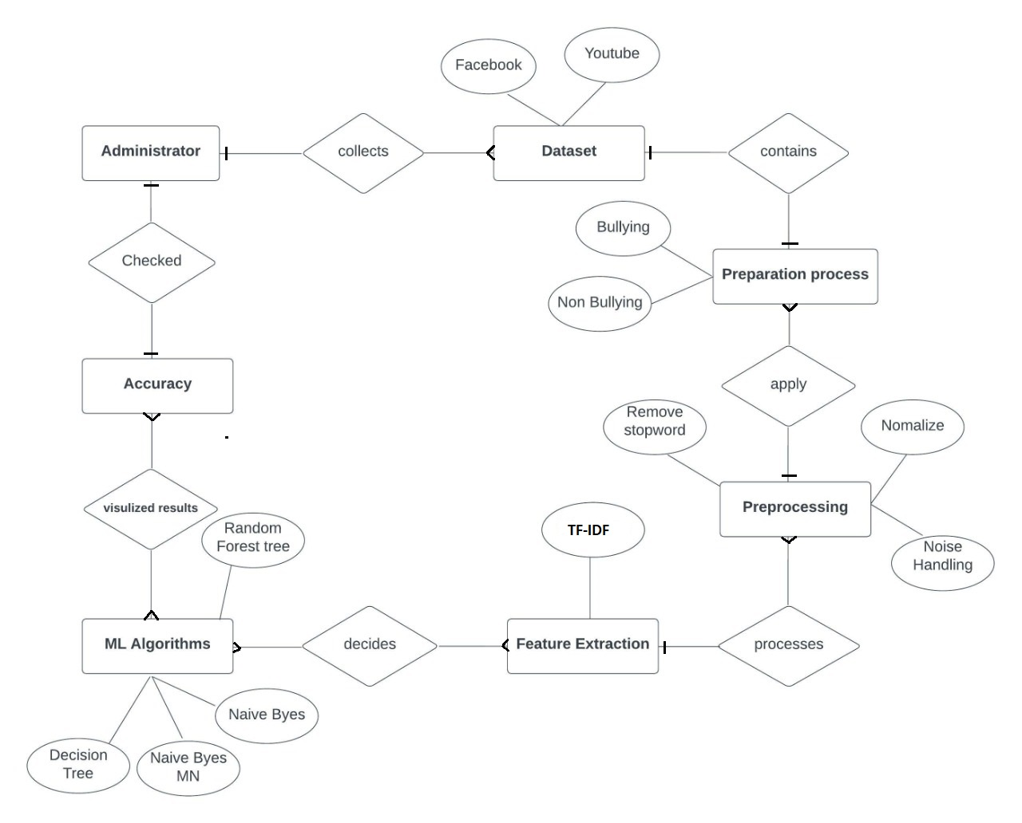
Figure 10 ERD of Cyber-bullying Detection

2.9 Graphical User Interfaces

2.9.1 Test case 1:

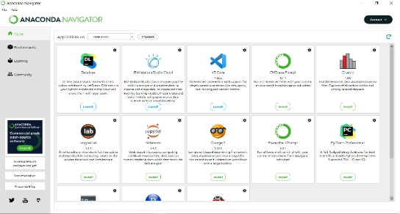
Figure 11 Test case1 Anaconda Interface

2.9.2 Test case 2:

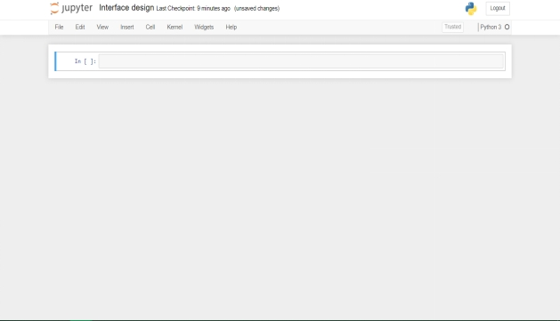
Figure 12 Test case 2 Jupytor Interface

2.9.3 Test case 3:

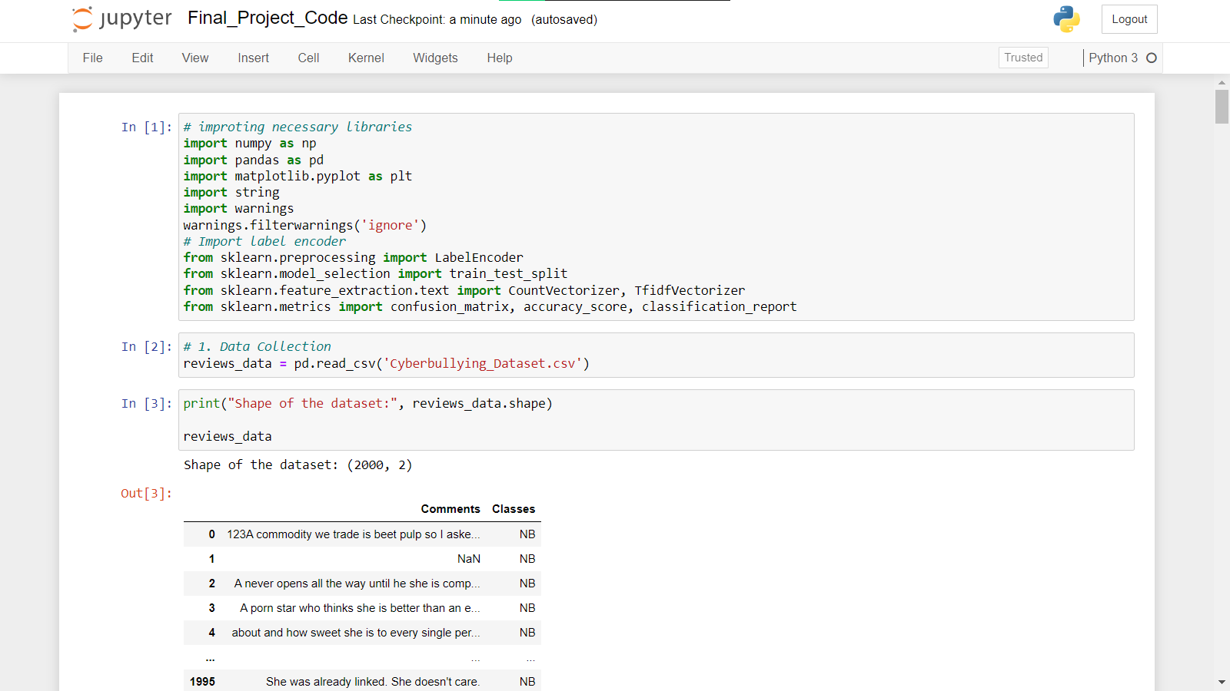
Figure 13 Test case3 Final Code Using Python

2.9.4 Test case 4:

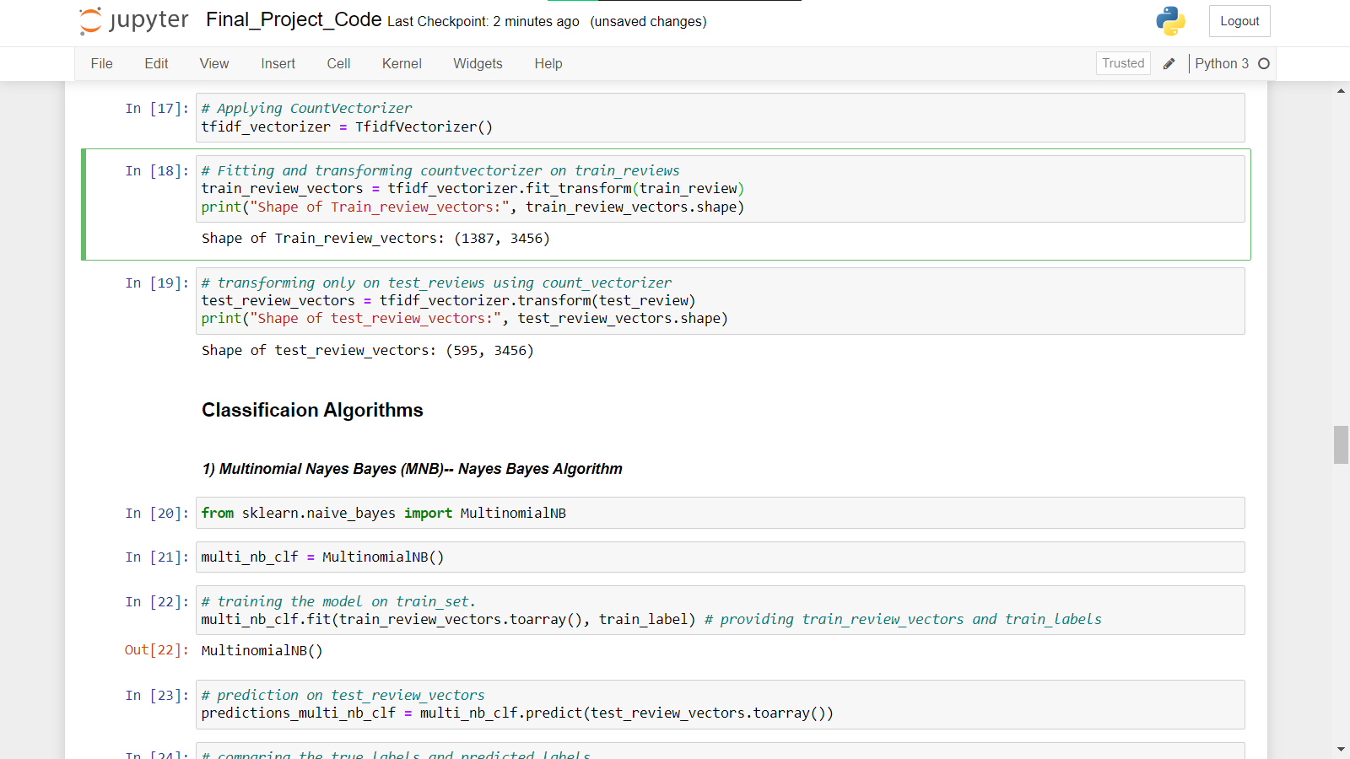
Figure 14 Test case 4 Classification of Algorithms

2.9.5 Test case 5:

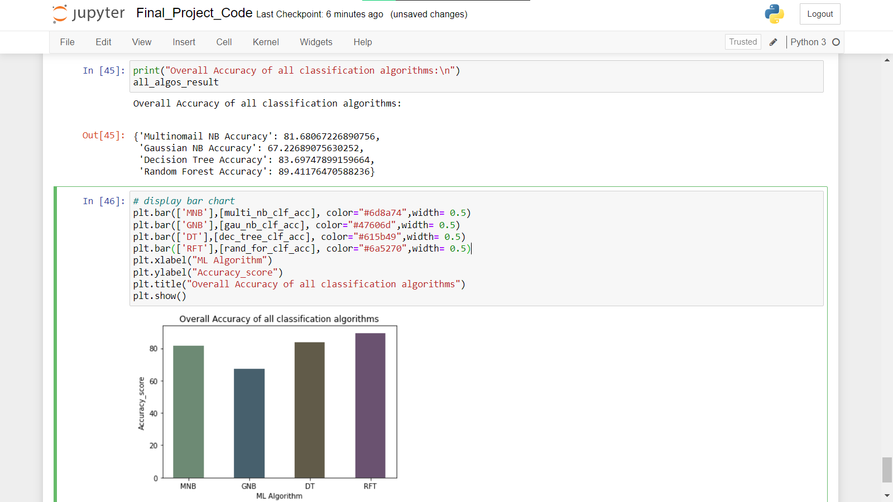
Figure 15 Test case 5 Accuracy score of ML Techniques

2.10 Test Cases Scenario
Table 12 Test Case1
Test case Id | TC1
Test case Name | Anaconda
Pre-condition | Open Anaconda
Actions | Install Jupyter Notebook
Post-Condition | Installed successfully
Expected Results | Auto launch
Result | Opened
Tested by | F2102102BC

Table 13 Test case2
Test case Id | TC2
Test case Name | Interface Design
Pre-condition | Open Anaconda
Actions | Open Jupyter Notebook
Post-Condition | Python 3 opened
Expected Results | Auto launch
Result | Successfully work
Tested by | F2102102BC

Table 14 Test Case3
Test case Id | TC3
Test case Name | Jupytor_notebook
Pre-condition | Open python 3 kernel
Actions | Worked on Jupyter Notebook
Post-Condition | Upload dataset
Expected Results | Auto launch
Result | Successfully run using libraries
Tested by | F2102102BC

Table 15 Test Case4
Test case Id | TC4
Test case Name | Final_code
Pre-condition | Open Jupytor_notebook
Actions | Review data
Post-Condition | ML techniques worked
Expected Results | Auto launch
Result | Get result
Tested by | F2102102BC

Table 16 Test case5
Test case Id | TC5
Test case Name | Final_code_work
Pre-condition | Open Jupytor Notebook
Actions | Install Jupyter Notebook
Post-Condition | Checked accuracy
Expected Results | Auto launch
Result | ML accuracy evaluation
Tested by | F2102102BC

CHAPTER 3

Development

3.1 Development Plan

Python programming will be used to construct this project. First, we'll look for and download the dataset, which will be used to train the model. After downloading, the data will be pre-processed before being transmitted to TF-IDF. The dataset is then trained and a model is
generated individually using Naive Bayes, Naive Bayes MN and Decision Tree and Forest Decision Tree algorithms. We use Python as the backend.

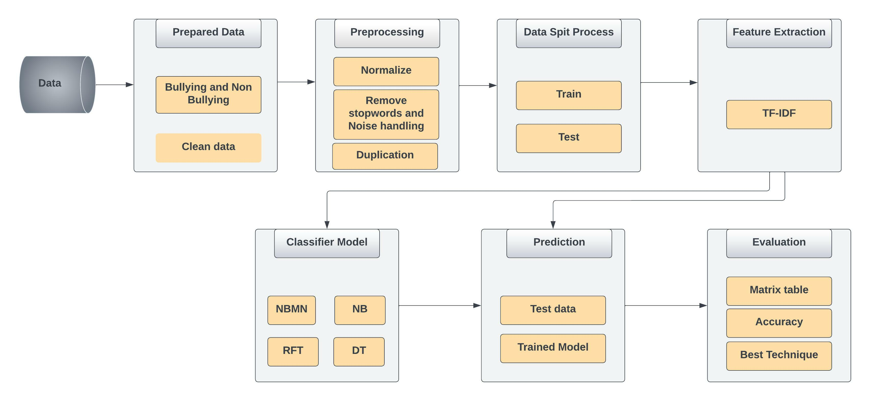
Figure 16 Development plan of Cyber-Bullying Detection using Machine Learning Techniques

3.1.1 Technique of detection:

The research methodology includes the following sections.

3.1.1.1 Dataset Collection & Preparation
The availability of datasets is important for analysis. A classifier's performance is determined by the dataset's quality and size. The dataset contains 2000 comments. Such information can be obtained through social media and YouTube comments. Once the dataset is ready, it must be divided into two categories: bullying and non-bullying.

3.1.1.2 Pre-Processing
The sentimental analysis in this process uses the Scikit-Learn Process Model. The Twitter postings and the associated sentiment labels were divided using the scikit-train test split learns a tool. A total of 70% of the samples were used for testing, and 30% were used for training.
Stop words and tokens are the two main categories of stylistics that are employed for preprocessing. Stop words, such as a, the, and across, are the most frequent words in a language. Tokens are instances of a group of characters in a document that are processed as a semantic unit (ScikitLearn, 2022).

3.1.1.3 Feature extraction or Modeling
The process of translating raw data into numerical features that can be processed while keeping the information in the original data set is known as feature extraction. We employed TF-IDF feature extraction methods in this proposed methodology.
The way term frequency works is by examining how frequently a specific phrase is used in relation to the document. How frequently (or infrequently) a term appears in the corpus is examined via inverse document frequency. A term's frequency in a document is revealed by TF, while its relative rarity within the collection of documents is revealed by IDF. We may calculate our final TF-IDF value by averaging these numbers.
TF-IDF algorithm: tf-idf(t,d,D) = tf(t,d) x idf (t,d)

3.1.2 Machine Learning Classification:

To predict the sentiment of Twitter postings, a number of classifiers were constructed using the scikit-learn machine-learning package (Gaikwad, 2021). Naive Bayes, Naive Bayes, Decision Tree, and Random Forest Tree are some of these classifiers. The fit approach was used to train each classifier on the scaled oversampled training data after each classifier had been started (Colab, 2021). The test dataset was then classified using the predict technique, and the accuracy score method from the metrics library of sci-kit-learn was used to assess the test's efficacy. The most effective classifiers, as shown in Table 17, were Decision Tree and Random Forest Tree. The classifiers' accuracy rating was noted.
Table 17 Accuracy Percentage by Classifier and Training Model
Classifier | Training Model | Accuracy %
Multinomial Naïve Byes | TF-IDF | 82
Gaussian Naïve Byes | TF-IDF | 67
Random Forest | TF-IDF | 84
Decision Tree | TF-IDF | 90

3.2 Evaluation and deployment:
Accuracy, recall, and precision will be used to evaluate the performance of the various classification models. To determine which models are best for classification, a table comparison of various models will be shown here (Adobe, 2022). The different classifier models will be iterated four times to record any accuracy variations. When analyzing the final findings, the process will be beneficial.

Table 18 Classification Report of Multinomial Naïve Byes
 | Precision | Recall | F1-score | Support
NB | 0.77 | 0.99 | 0.87 | 357
B | 0.97 | 0.56 | 0.71 | 238
Accuracy |  |  | 0.82 | 595
Macro-average | 0.87 | 0.77 | 0.71 | 595
Weighted-average | 0.85 | 0.82 | 0.80 | 595

The Multinomial Nave Byes' performance for each sentiment class is described in the classification report. With a precision rate of 77% and an F1-score of 87%, the classifier correctly predicted 357 negative test instances, or 99 percent, for the negative class. With a precision rate of 97 percent and an F1-score of 71 percent, the classifier correctly predicted 56 percent of the 238 positive test examples for the positive class.

Table 19 Classification Report of Naïve Bayes
 | Precision | Recall | F1-score | Support
NB | 0.78 | 0.64 | 0.70 | 357
B | 0.57 | 0.72 | 0.64 | 238
Accuracy |  |  | 0.67 | 595
Macro-average | 0.67 | 0.68 | 0.67 | 595
Weighted-average | 0.69 | 0.67 | 0.68 | 595

The Nave Byes' performance for each sentiment class is described in the categorization report. With a precision rate of 78% and an F1-score of 70%, the classifier correctly predicted 64% of the 357 negative test examples for the negative class. With a precision rate of 57% and an F1-score of 64%, the classifier correctly predicted 64% of the 238 positive test examples for the positive class.
Table 20 Classification Report of Decision Tree
 | Precision | Recall | F1-score | Support
NB | 0.86 | 0.87 | 0.87 | 357
B | 0.80 | 0.79 | 0.80 | 238
Accuracy |  |  | 0.84 | 595
Macro-average | 0.83 | 0.83 | 0.83 | 595
Weighted-average | 0.84 | 0.84 | 0.84 | 595

The Nave Byes' performance for each sentiment class is described in the categorization report. With a precision rate of 86% and an F1-score of 87%, the classifier successfully predicted 357 out of 357 negative test examples for the negative class. With an F1-score of 80% and an accuracy rate of 80%, the classifier correctly predicted 79 percent of the 238 positive test examples for the positive class.

Table 21 Classification Report of Random Forest Tree
 | Precision | Recall | F1-score | Support
NB | 0.93 | 0.90 | 0.91 | 357
B | 0.86 | 0.89 | 0.88 | 238
Accuracy |  |  | 0.90 | 595
Macro-average | 0.89 | 0.90 | 0.90 | 595
Weighted-average | 0.90 | 0.90 | 0.90 | 595

The Nave Byes' performance for each sentiment class is described in the categorization report. With a precision rate of 86% and an F1-score of 87%, the classifier successfully predicted 357 out of 357 negative test examples for the negative class. With an F1-score of 80% and an accuracy rate of 80%, the classifier correctly predicted 79 percent of the 238 positive test examples for the positive class.

3.3 Conclusion

The objective of this research is to automatically identify social media posts that pertain to cyberbullying. Manual monitoring for cyberbullying is no longer practical due to the information overload on the internet. It would be easy to control and respond swiftly when necessary if cyberbullying flags were automatically detected. These remarks, however, can also require proof of ongoing cyberbullying. This development's purpose is to develop a system that can automatically identify signs of cyberbullying on social media, including various forms of cyberbullying and postings by bullies, victims, and observers.

3.4 FUTURE SCOPE
Future study will focus on enhancing the effectiveness of our classifier by using additional input Characteristics, such as fresh picture features, commenting behavior over time, sensor data from mobile devices, etc. Our present classifier has the drawback of being solely intended for really unpleasant media sessions. There is a need for a broader classifier that can be used for all media sessions. We will also need to significantly expand our labeled data collection to do this.
Automating the incorporation of picture characteristics requires the use of image recognition algorithms.
Future improvements to the technology will focus on detecting whether or not cyberbullying is occurring by using more precise datasets. We also use different machine learning algorithms and evaluate the precision of the models. Bullying will be easier to identify with a higher accuracy model.

REFERENCES

- Preventing the Occurrence of Cyber Bulling Messages on Online . (2019). Computer Science and Engineering, 22-51.

- McNally Institutes. (2022, April 28). Retrieved from Software Engineering: https://www.mcnallyinstitute.com/what-is-design-document-in-software-engineering/

- Metrics and scoring: quantifying the quality of predictions. (2022, February 2). Retrieved from ScikitLearn: https://scikit-learn.org/stable/modules/model_evaluation.html

- Adobe. (2022, April 22). XD. Retrieved from Reader: https://xd.adobe.com/ideas/principles/web-design/design-documentation/#:~:text=Design%20documentation%20is%20a%20collection,and%20stakeholders%20have%20agreed%20on.

- Chuaudhry, M. (2020). TF-IDF Vectorizer scikit-learn. Medium, 22-33.

- Colab. (2021, February 11). MkDocs. Retrieved from Zero to Mastery TensorFlow for Deep Learning: https://dev.mrdbourke.com/tensorflow-deep-learning/08_introduction_to_nlp_in_tensorflow/#

- Cyberian. (2021, April). Cyber. Retrieved from VU process model: https://cyberian.pk/topic/2147/vu-process-model/1?lang=en-US

- Gaikwad, C. (2021). Detection of Cyberbullying Incidents on Instagram Social . International Journal of Research in Engineering and Science, 09-13.

- Javed, R. (2019, December 3). Online CS Master. Retrieved from Methodology: http://freestudenthelp.blogspot.com/2019/12/methodology-in-srs-vu-process-model.html

- Nirmal, N. (2020). Automated Detection of Cyberbullying Using Machine Learning. INTERNATIONAL RESEARCH JOURNAL OF ENGINEERING AND TECHNOLOGY, 2061.

- ResearchGate. (2022, January). ResearchGate. Retrieved from Methods Used in Cyberbullying Research: https://www.researchgate.net/publication/278668405_Methods_Used_in_Cyberbullying_Research

- ScikitLearn. (2022, January 3). ScikitLearn. Retrieved from Feature Extraction: https://scikit-learn.org/stable/modules/feature_extraction.html#tfidf-term-weighting

- Ziman, P. (2021). International Journal of Research in Engineering and Science. Detection of Cyberbullying Incidents on Instagram Social Network, 06-13.

APPENDIX A

Project Title: Detection of Cyber-bullying using Machine Learning

Principal Investigator:
- Tayyba (MC200403615) Masters in Computer Science, Virtual University of Lahore.
- Hiba Nishat Anjum (MC200403928) Masters in Computer Science, Virtual University of Lahore
Supervisor’s Name: Muhammad Tayyab Waqar, Virtual University of Lahore

Purpose of the Study:
This study explores the Machine learning techniques to detect the Cybebullying.
Procedure:
- Working on Cyberbullying Dataset
- Used Classification Algorithms
- Find best Accuracy
- Used Anaconda for Python Framework
- Python Language used

Appendix B

Anaconda version 1.7.2 is a distribution of the Python and R programming languages for scientific computing (data science, machine learning applications, large-scale data processing, predictive analytics, etc.), that aims to simplify package management and deployment.
We are using version 1.7.2 of Anaconda-2021 and using the following libraries:
- Scientifics Computing Libraries
Pandas
Data structure & tools
Numpy
Arrays & Matrices
Scipy
Integrals, solving differential equations and optimization

- Visualization Libraries
Matplotlib
Plots & graphs
- Algorithmic Libraries
Scikit-learn
Classification
Stats-models
Explore data, estimate statically models, and perform statically tests.

Appendix C

Appendix D

